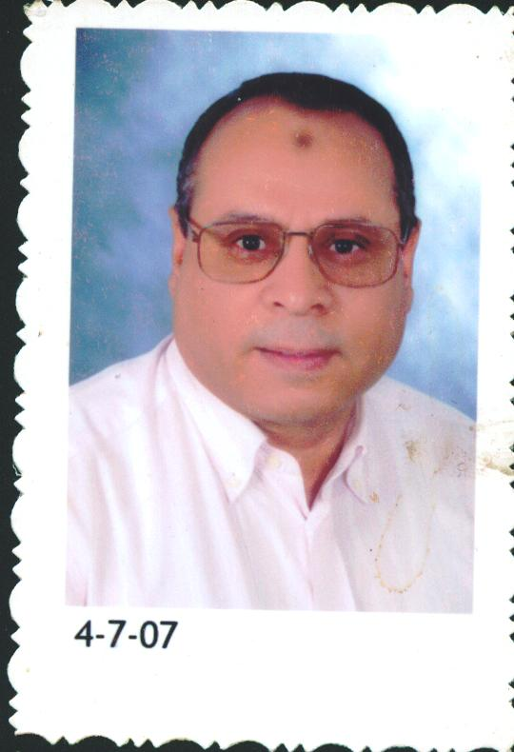

Dr. Mohamed A. Mohamed
Geology Deptartment
Faculty of Science
Assiut University
Assiut-71516 Egypt
e-mail: m_moneim58@yahoo.com
Mobil: 0163311545

CURRICULUM VITAE

I. Personal Data:
Date of Birth: December 8, 1958.
Place of Birth: El-Minia Egypt.
Present Employment: Assistant Professor Geology Department, Faculty of Science, Assiut
University, Egypt.
Teaching Experience: Mineral deposits, Geochemistry, Mineralogy, and Crystalline rocks
Research Interests: Geochemistry and mineral resorces.
Membership of Scientific Societies:
- Member of the Egyptian Geological Society.
- Member of the Mineralogical Society of Egypt.
- Member of arab meteors-space association(AMSSA)

II. University Education:

Time University Place, Country Main Subjects
Oct. 1976- Assiut Assiut - Egypt B.Sc courses:
Geology, Zoology,
June 1980. Botany, Mathematics
Physics, Chemistry.
June 1982- Assiut Assiut - Egypt M.Sc. Courses:
June 1986. Economic Geology and Ore
Microscopy, Field Geology,
Structural Geology,
and Photo Geology.
Jan. 1992- Charles Prague-Czech Ph.D. Courses:
June 1993 1. Ore deposits-Types and Models
2.Stable and Radiogenic isotope
Geochemistry.
3. Geology of Czech Republic
4. Geochemistry of granites
5. Interpretation of Geochemical
data.
6. Thermodynamics of magma
June 1993- Charles Prague-Czech Ph.D. Research.
Aug. 1996.

III. Academic Degrees:

Year Degree University Place, Country Subject
1980 B.Sc. Assiut Assiut - Egypt Geology
1986 M.Sc. Assiut Assiut - Egypt Mineral Exploration
1996 Ph.D. Charles Prague - Czech Mineralized granites

IV. Professional Background:

Time Position Institute
Oct. 1980- Demonstrator Assiut University,
June 1986. ( Teaching & Research ) Assiut - Egypt.
June 1986- Assistant Lecturer Assiut University,
Sept. 1991. ( Teaching & Research ) Asset -Egypt.
Janu. 1992- Research Scholarship Charles University,
Aug. 1996. Prague-Czech.
Oct. 1996 Lecturer Assiut-University (Teaching & Research) Assiut - Egypt.
Sept. 2003 Assistant Professor Assiut University- Egypt

V. Periods of study and research abroad :
Scholarship for Ph.D. study from Sept.1991 to Aug. 1996 Ph.D. in Charles University-Prague-Czech Republic.

VI. Scientific Missions
- To Vienna University of Technology-Institute of Engineering Geology from 20 May to 10 June 2005. To complete the research project in the Dokhan Volcanic, Eastern Deseret, Egypt.
- To Martin Luther University – Halle- Germany, from 10 to 18 March 2007: Tranaimg in environmental geochemistry center to establish environmental geochemistry lab. (TEMPUS PROJECT).
- To Belgium from 1-14 September 2008: International Summer course on sustanible water mangment and technology in Urbanized areas ISC (TEMPUS PROGRAMME)
- Ti lund University – Sweedenfrom3-28 October 2010, scientific research project on granites of Egypt.
- To Martin Luther University – Halle- Germany, from 15 Feb. to 18 March 2011: Tranaimg in INDUSTRIAL MINERAL AND ROCKS (TEMPUS PROJECT).

VI. Supervision of the Scientific degrees (MS.c and PH.D):
Supervisor on five master degree, four of them were awarded, and two Ph.D degrees.

VII. List of Publications
1. Mohamed, M.A., and Bishara, W.W., 1998. Fluid inclusions study of Sn-W mineralization at Igla area Central Eastern Desert, Egypt. Egyptian Journal of Geology, v. 42/1, pp. 207-220

2. Mohamed, M.A., and El-Nady, O.M., 1999. Petrochemistry and geochemistry of Gabal Igla El-Ahmar composite granite pluton, Central Eastern Desert of Egypt. The First International Conference on the Geology of Africa. Assiut University, Egypt. V.2, pp.141-157

3. El-Metwally, M.A., Mohamed, M.A., Mashaal, Sh.E., El-Tokhy, M.M., and Azza A. Ragab., 1999. Fluid inclusions of younger granites, pegmatites and beryl from South-Eastern Sinai, Egypt. The First International Conference on the Geology of Africa. Assiut University, Egypt V.1pp.403-419.

4. Mohamed, M.A., and Elhaddad, M.A., 2001. Geochemistry and evolution of ore-forming fluids of Gebel Ras-Barud rare-metal granite and pegmatite. Eastern Desert, Egypt. The second International Conference on the Geology of Africa. Assiut University, Egypt. V.2 pp. 143-165.

5. Heikel, M.T.S., Moharem, A.F., Mohamed, M.A., 2001. Origin and radioactive signature of fluorite megacrysts in potassic alkali rhyolite from Hormuz Complex, Dalma Island, United Arab Emirates.5th Inter. Conf. On Geochemistry. Alex. Univ. Egypt. pp. 373-393.

6. Mohamed, M.A., and Hassan, G.S., 2002. Estimation of uranium and thorium concentrations in non-mineralized and mineralized granite, Gabal Gattar area, Eastern Desert, Egypt. Sixth Radiation Physics Conference, Assiut University. Arab Journal of Nuclear Sciences and Applications, vol.36 (in press).

7. Asran, M.H., and Mohamed .M.A., 2003. Geochemistry, Petrogenesis and fluid inclusion studies of Kadabora composite granite pluton and associated mafic microgranular enclaves, Central Eastern Desert, Egypt. Fifth International Conference on the Geology of the Middle East. P. 139-154.

8. Mohamed, M.A., 2003. Hydrothermal alterations and evolution of mineralizing fluids of Gabal Gattar granite, Eastern Desert, Egypt. BULL. FAC.SCI, ASSUIT UNIV. 32(1-F) P-P. 23-39(2003)

ثاييا: ا الأبحاث المنشورة منذ عام 2005-حتى 2011
9. M.A.Mohamed, H. Kurzweil, and E.A.Ahmed, 2005: Fluid Inclusions Study of Recent and Miocene Evaporites, Gulf of Suez Coast, Egypt. Forth International Conference on the Geology of Africa. Assiut University, Egypt, V. 1, P. 105-113.

10. M. A.Mohamed, H. Kurzweil, and E.A.Ahmed, 2007: Surface prospecting for oil along the Red Sea coast, Egypt using fluid inclusion and geochemistry of evaporites USING. THE Fifth International Conference on the Geology of Africa, Vol. (1), P-P. III-55 – III-62 (OCT. 2007) ASSIUT-EGYPT

11. Ahmed, M. Y; & Asran M. H; & Mohamed, M.,A., 2008: Integration of remote sensing data with the field and laboratory investigation for lithological mapping of granitic phases: Kadabora pluton, Eastern Desert, Egypt. Arab J Geosci (2009) 2:69–82, Arab J Geosci (2009) 2:69–82, online DOI 10.1007/s12517-008-0020-2.

12. Abdel-Aziz, Y.M; Mohamed, M.A; Mohamed, H.A; Amadeu, M, 2008 Fluid inclusions and mineral chemistry of some detrital heavy minerals of alluvium sediments from Meluli-Namuhuca area, Mozambique. Journal of Geology and Mining Research Vol. 1(1) pp. 001-007. Available online http://www.academicjournals.org/jgmr.

13. M.A.Mohamed and F.F.Abu-Ela, 2009: Geochemistry and fluid inclusions study of highly fractionated garnet-bearing granite of Gabal Abu Diab, central Eastern Desert of Egypt. Arab J Geosci. Online paper DOI 10.1007/s12517-009-0088-3

14. 6. Mohamed , M.A., El Habaak, G. H., Bishara, W. W; El Hadek, H. H (2009): Geochemistry and microthermometry of Homr Akarem and Homret Mikpid rare – metal granites, South Eastern Desert, Egypt. The Sixth International Conference on the Geology of Africa, P-P V- 61 – V-87 (OCT. 2009) ASSIUT-EGYPT

15. Mohamed , M.A (2010): Geochemistry and fluid evolution of the peralkaline rare-metal granite, Gabal Gharib, Eastern Desert of Egypt. Arab J Geosci. Online paper. DOI 10.1007/s12517-010-0244-9

16. Mohamed , M.A (2011): Evolution of mineralizing fluids of cassiterite-wolframite and fluorite from Mueilha tin mine area, Eastern Desert of Egypt., evidence from fluid inclusions. Assiut Univ. J. of Geology, 40(1),1-18, Assiut

17. Mohamed , M.A., El Habaak, G. H., Bishara, W. W; El Hadek, H. H (2011): Geochemical and fluid inclusions studies of fluorite mineralization at Homr Akarem and Homret Mikpid granites, South Eastern Desert, Egypt. Assiut Univ.J.of Geology. 40(1), 19-33, 2011.

18. Mohamed, M.A (2012): Immiscibilty between silicate magma and aqueous fluids in Egyptian rare-metal granites: melt and fluid inclusions study. Arab J Geosci DOI 0.1007/s12517-012-0664-9

19. Mohamed A. Moneim, Ezzat A. Ahmed (2015): Synthesis of Faujasite from Egyptian Clays: Characterizations and Removal of Heavy Metals. Geomaterials, 2015, 5, 68-76.
http://www.scirp.org/journal/gm/

20. Gameh, M.A; A.S.Ebtehag; G.H. El-Habaak and M.M.Abdel-Moneim (2014): Groundwater Potentiality and Suitability for Drinking and Irrigation in the New Valley, Western Desert, Egypt. Assiut J. Aric.SCI., (45) No.(2), 113-124, Special Issue.

21. Ahmed A Geies; Mahmoud M. Sanousy; Mohamed Abdul-Moneim; and Seham O. Farghaly (2013): Utilization of Ion Exchange Resins: Ambersep GT74 and Amberlyst A21 in purification of Drinking Ground Water and its Characterization. Egyptian Sugar Journal.

22. El-Habaak; A.S.Ebtehag; G.H. Gameh, M.A; and M.M.Abdel-Moneim (2013): Study and interpretation of Iron Removal from the Groundwater in the New Vally, Western Desert, Egypt. Seventh International Conference on the Geology of Africa. ABSTRACT.

23. M.Abdel-Moneim; M.H.Abd-Allah; E.A.Kheila; M.A.Essa and M.A.Ishak (2013): Evaluation of the surface water in Assiut city as drinking source before and after treatment. Seventh International Conference on the Geology of Africa. ABSTRACT.

24. M.Abdel-Moneim; M.M.Sanousy; A.Abdu-Geies and S.O.Farghaly (2013): Hydrochemical evaluation of drinking groundwater in El-FATH District, Assiut-Egypt. Seventh International Conference on the Geology of Africa. ABSTRACT.

25. Omer Yehya; M.Saber, M. Abdel-Moneim and E.A.Kheila (2013):Groundwater quality evaluation condidering the environmental impact of groundwater level uprising at Fares area, Aswan, Egypt. Seventh International Conference on the Geology of Africa. ABSTRACT.

